**Pearson**

**Higher Nationals in**

**Computing**

Unit 13: Computing Research Project

Project Proposal

**The challenges of work from home during social distancing time in the pandemic situation.**

By

**S. Vakshalan**

**00066985**

Submitted in accordance with the requirements for the  
**COMPUTING RESEARCH PROJECT MODULE OF PEARSON’S HND IN Computing software engineering PROGRAMME**  
at the  
**ESOFT METRO CAMPUS**

**Name of research Tutor:**

**The challenges of work from home during social distancing time in the pandemic situation**

**2023/01/21**

# DECLARATION

Name of Research Candidate: Sivapalasuntharam Vakshalan

Pearson Registration Number: 00066985

Programme Name: CRP

Research Title: The challenges of work from home during social distanceing time in the pandemic situation

Field of Study:

I do solemnly and sincerely declare that:

* 1. I’m the sole author of this study
  2. This work is original
  3. In case of any use if any information from other sources references of copyright with its ownership have been acknowledged in this document
  4. I do not have any actual knowledge, nor do I ought reasonably to know that the making of the work constitutes an infringement of any copyright work
  5. I know that plagiarism is a punishable offence because it constitutes theft, I understand the plagiarism and copying policy of the Edexcel UK, I know what the consequences will be if I plagiaries or copy another’s work in this research for this program.

Candidate Signature: …………………………… Date: ……………….

Subscribed and solemnly declared before,

Supervisor’s Name: ……………………………………………………………….

Designation: …………………………………….

Supervisor’s Signature: …………………………. Date: ……………….

# ACKNOWLEDGMENT

I would like to extend my deepest gratitude to all those who helped me to complete this project proposal report documentation. A special thanks goes to our supervisor, [Ms/Mr name], whose helped me to coordinate my project especially in finding information and to finalize this report, encourage me and for the stimulating suggestions.

Not only that, but also need to thank you for that you have invested your full effort in guiding me in achieving my goal. Furthermore, I would also like to thank my parents for their endless love and support. Last but not least, I would like to thank my lecturers for letting me to use this issue for my project report.

# ABSTRACT

Due to the covid 19 pandemic situation most of the companies recommended to the employees to do their work in online method. Regarding the unforeseen situation it was a big challenge to maintain the productivity in online method as same level as working in the office and it was hard thing to train the employees to work with the online method. At the beginning of the pandemic situation, most of the employees who had not much computer knowledge or modern technology knowledge have faced so may difficulties of adopting to use online tools. Moreover, they couldn’t manage their working hours with their daily routines. With this paper outlines a survey conducted amongst employees who are working from home to identify the challenges this change in workstyle offers. However, according to the survey, the final results show us that within a small amount of period the employees could be able to manage their own work and develop the necessary knowledge and skills for working remotely. Nevertheless, we could be able to identify that how they manage the digital tools, collaborating with other employees in online platforms, the problems they have faceted and how they could manage workload when using online tools. Most of the employees recognized the advantage of remote working as same as the negative impacts of it. Likewise, within the context of this paper it is discussed about the challenges of work from home during social distancing time in the pandemic situation.

# CONTENTS

**DECLARATION** ii

**ACKNOWLEDGMENT** iii

**ABSTRACT** iv

**CONTENTS** v

**A LIST OF TABLES** vii

**LIST OF FIGURES** viix

**CHAPTER 1 – INTRODUCTION** 1

**1.1.** **Introduction**………………………………………………………………...1

**1.2.** **Purpose of research...**…………………….………………………………...7

**1.3.** **Significance of the Research**……………………………………………….7

**1.4.** **Research objectives**………………………………………………………...8

**1.5.** **Research Sub objectives**……………………………………………………8

**1.6.** **Research questions**…………………………………………………………9

**1.7.** **Hypothesis**… …………………………………………………………….11

**1.8.** **Thesis structure...**…………………………………………………………12

**CHAPTER 2 - LITERATURE REVIEW** 13

**2.1.** **Literature Review**…………………………………………..……………..13

**2.2.** **Conceptual framework**…………………………..……………………….15

**CHAPTER 3 - METHODOLOGY** 16

**3.1.** **Research philosophy**…………..………………………………………….16

**3.2.** **Research strategy**…………………..……………………………………..16

**3.3.** **Time frame**……………………………………….………………………..17

**3.4.** **Data collection procedures**………………..……………………………...18

**3.6.2.** **Data Collection Method**…..………………………………………………18

**3.6.3.** **Data Collection and Analyze Tools**……………………..………………..18

**3.5.** **Ethical issues of the research study**………………………………………19

**CHAPTER 4 - PRESENTATION OF RESULTS** 20

**4.1.** **Demographic Analysis**………………………..…………………………..20

**4.2.** **Regression Analysis**……………………...………………………………..21

**CHAPTER 5 - CONCLUSIONS AND RECOMMENDATIONS** 22

**5.1.** **Conclusion**………………………......…………………………………….22

**5.2.** **Limitations**…………………...…...……………………………………….23

**5.4.** **Future Improvements**…………………..………………………………...23

**5.5.** **Personnel Reflection**………………...…………………………………….24

**5.5.1.** **Benefits for the researcher** 24

**5.5.2.** **Benefits for the Industry/organization** 24

**Referencing** 25

**Annexures** 27

Annexures A: Glossary of Terms………………………………………………………27

Annexures B: Sample SPSS Charts/ Table…………………………………………….28

Annexures C: Feedback Form / Question list………………………………………….29

Annexures D: Sample Feedback sheets………………………………………………..30

# A LIST OF TABLES

# LIST OF FIGURES

Figure 1.1.1 Management Views on Working from Home 1

Figure 1.1.2 Challenges of remote working 2

Figure 1.1.3 Struggling with working remotely 3

Figure 1.1.4 Software’s that Using for online communication 4

Figure 1.1.5 Reasons for software selection 5

Figure 1.6.1 Recognized problems of companies 10

Figure 1.6.2 Challenges of remote working 10

Figure 1.8.1 Thesis structure 12

Figure 2.2.1 Conceptual framework15

Figure 3.3.1 Time frame 17

Figure 4.2.1 Demographic analysis of the research study 20

Figure 4.2.1 Regression Analysis 21

# CHAPTER 1 – INTRODUCTION

## Introduction

In near 2019 not only in China but also all over the world have faced a huge problem called COVID-19 pandemic. As we know, the COVID-19 pandemic situation has been without a doubt exacerbated mainly in economic and social challenges across all the countries. Most of the people died because of this pandemic. Regarding this situation mainly companies, were faced so many problems by maintain their work. It was a huge challenge to maintain their productivity as same as in this pandemic situation and they need to be connected with customers to do to succeed their work.

Therefore, due to the covid 19 pandemic situation most of the companies need the employees to do their work with connecting with each other and maintain their productivity. They thought to change the nature of the work. They have recommended that work form home because the whole country needs to face that problem as much as they can (“Ovidius” University Annals, 2020). So that as the result the found a solution that to connecting with others and maintain their productivity by working remotely.

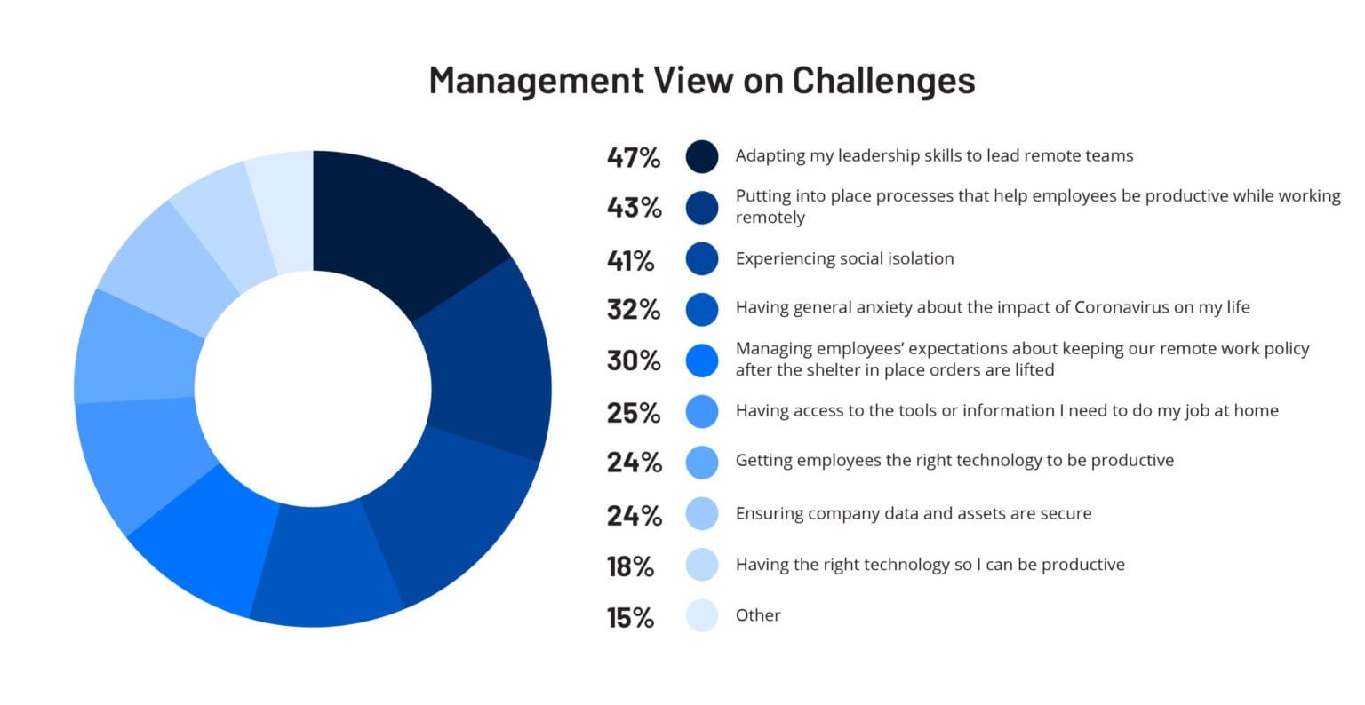

Figure 1.1.1: Management Views on Working from Home

Acoording to our servey we asked that both companies and the workers that what are the challenges they have faceed durng working remotely. Regarding the pie chart below, more that 40% of company owners have struggled mostly with adapting how to lead a remote workforce with the workers who had never working remotely before (Bluescape, 2020). However we could be able to analize all the problems that are facing by the companies regarding to this COVID-19 pandemic situation.

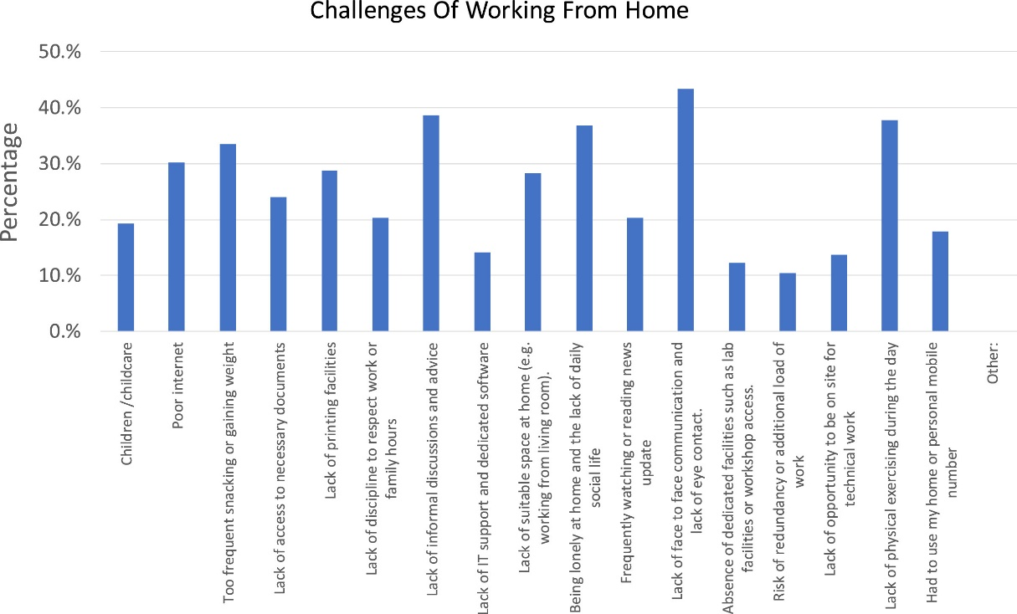

Figure 1.1.2: Challenges of remote working

According to the diagram that, we could be seen that the challenges that the workers have faces during the pandemic situation (Market Insights, Growth & Productivity, 2020). As the employees it was hard to practice working remotely because most of them were never have any experience of working from home previously. However, all must to face that problem as this is global pandemic situation. In that case the companies need to help the employees t train their employees for working remotely by using digital tools and keep the connectivity with each other.

Most of the developed counties have already used the online digital tool for do their task easily (JMIR Public Health Surveill., n.d.). So that they did not face more difficulties than others, but the developing countries and non-developed countries have faced so many difficulties when using online digital tools in working from home. Regarding this issue most of the companies should have been appointed some team to train who are that the beginners for online digital tools. It was a kind of a risk that they have taken on their entire working life because, they were never experienced the results of that. However, they take the risk and train all of the employees for working by using online methods and keep the connectivity with each other. The bellow pie chart clearly shows that (NAN JIANG and JULIE RYAN, 2020).

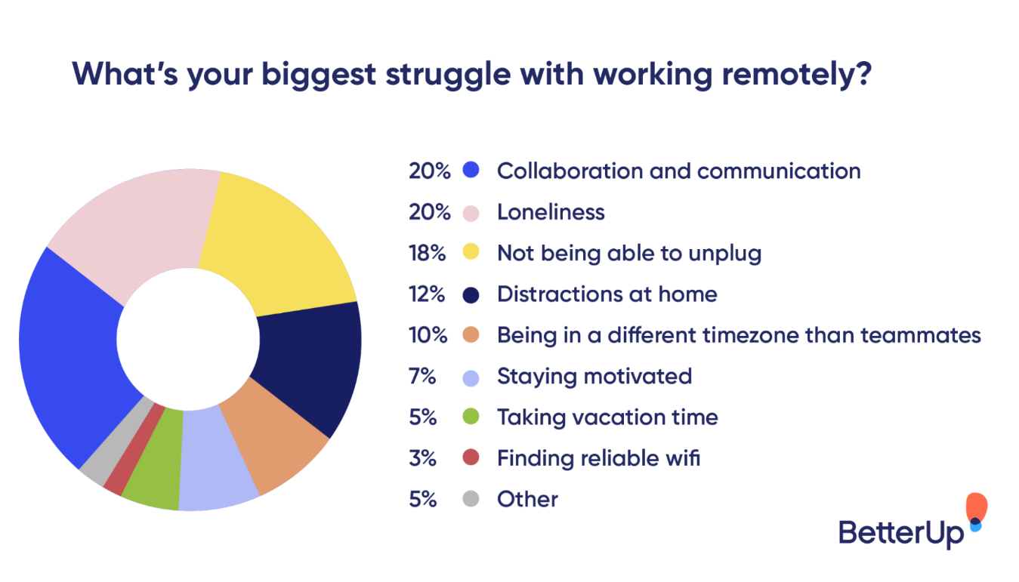

Figure 1.1.3: Struggling with working remotely

However according to this one we could be able to list down that what was the mostly effect the to the remote workers that 20% are struggling of collaboration and communicating with others and another 20% of workers struggling of the loneliness (fireflies.ai, 2021).

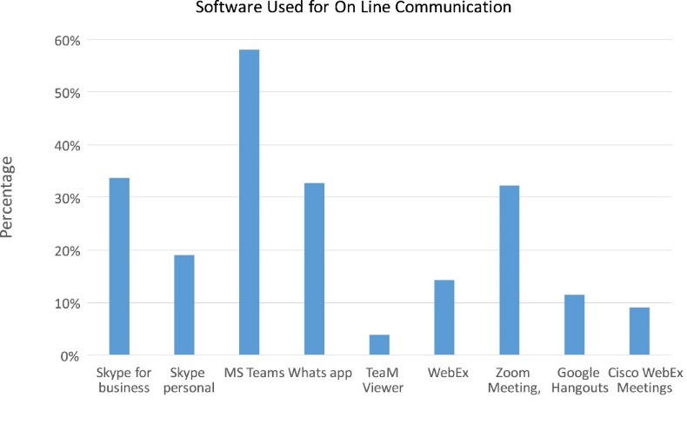

Figure 1.1.4: Software’s that Using for online communication

In here we could be able to know what are the software that can be use for online communication and to know what are the most useful software that the people are used to do their work with electronic devices. Regarding this we could be able to identify what was the most famous platform, least used software platforms as well (International Journal of Information Management, 2020).

Therefor according to the bar chart in here we could identify that most of the users like more than 58% of use **MS teams** as for communicate and do working from home (International Journal of Information Management, 2020). As same as near to 30% of users use **Skype for business, WhatsApp** and **Zoom meeting** platforms on their working period. Apart from that most famous software’s that are using

* Skype for personal
* WebEx
* TeaMViewer
* Google Hangouts
* Google meet
* Cisco WebEx Meetings

And also, we could be able to identify that how the employees were manage the digital tools, collaborating with other employees in online platforms. As mentioned before people have never faced this kind of a pandemic situation and most of employees never tried to work form home rather than go to the site and work. It was a huge difficulty to most of the employees who do not have any experience with working with online tools. As same as it was some kind of a new experience for them. According to the issue the companies should have to start giving a full training period for all of the employees who do not have much knowledge of using electronic devices and who need to be connected with the company in working hours. Having less than three months of a good training, the employees could be able to work by using online digital tools. After the training there were able to familiar with the electronic devises, digital tools and work from home (International Journal of Information Management, 2020).

For communicate with workers, the companies use so many technologies by researching them. The bellow diagram shows that how the companies selected the technologies for their working platforms and what are the reasons for the software selections.

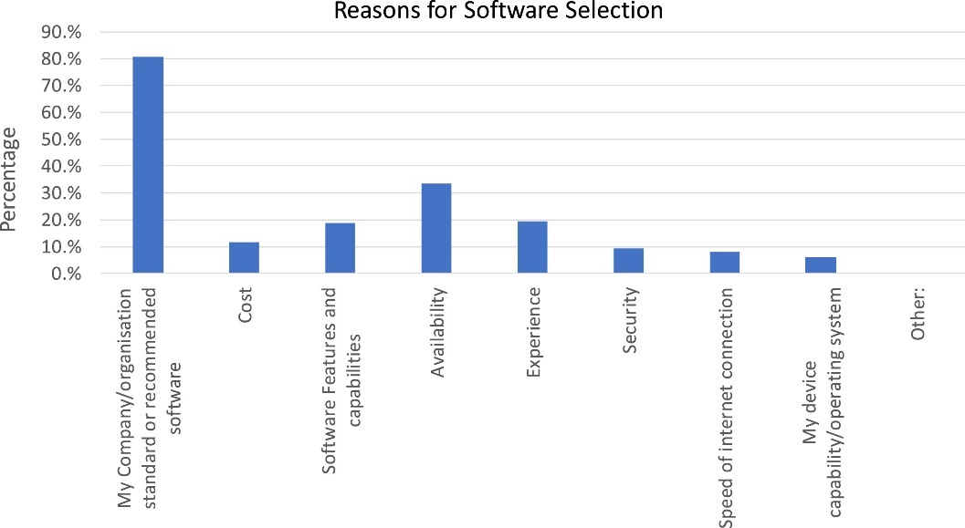

Figure 1.1.5: Reasons for software selection

However, then another problem was how to find electronic devices like laptops, computers, tablets, smartphones and etc because they need to spend some money for buy them from stalls. Nevertheless, when considering about employees, they need to consider that when more than one person in their family is working remotely, how far if it is possible that each family member is having a committed workspace where they can work without any disturbance. Therefore, the family members should have to arrange some specific places for each and every member for do their work without any disturbances. It was a challenge to some amount of people because they do not have that much space in their houses. As a solution for that problem each and every family has organized and take a plan to overcome that problem by separating places and manage small places for their need.

And the other problem is that most of the workers have struggled due to manage their working time and when the schools and institutes are closed, they need to work around childcare commitments (International Journal of Information Management, 2020). Workers need have some family meetings and then after they reach an agreement on how could be able to fit into their work-from-home schedule.

However, when there were so many challenges to face, the workers could be able to overcome the problems by using general knowledge and after then, they could be able to continue their productivity with making connection with each other. According to the Covid-19 pandemic has provided a unique opportunity to understand the potential for enhanced working from home (“Ovidius” University Annals, 2020).

## Purpose of research

By this it mainly focuses on the challenges for the workers who are working remotely. Because of the COVID 19 pandemic in last 2019, the companies and the workers had to find a better solution for maintain heir productivity continuously. Therefor they have decided to do their work from home. Developed countries had an experience of remote working but most of the companies had not that much experience. So that, it was a challenge to everyone including companies as same as the workers.

In that case, people need to face that kind of disasters any movement. Therefore, according to my opinion companies and as same as the workers need to know what the challenges are and how to face them better. So, regarding this research, it may really helpful for both workers and the companies to handle the challenges more comfortably.

## Significance of the Research

In this research, the readers could be able to know how far the COVID 19 pandemic affect to the economic in a country. When all the countries have faces this together and find a solution to maintain the country by not take any physical meeting, but doing online platforms. In here the reader could be able to find the challenges and opportunities of working remotely and how to face the challenges very strongly. That is the main purpose to make this research.

## Research objectives

In this research main objective is to recognize that what were the challenges working from which had to be faces during the COVID 19 pandemic situations, find the proper solutions for that. The proposed research not only that but also discussing about that how to be prepare for the future disasters and how to continue the productivity of the entire world with connecting with each other without meeting face to face and using online platforms. By this research it is ability to find out workers side problems as well as the companies side problems. Therefore, by considering about this research, companies and the employees could be able to maintain the productivity of the company without coming to the site but working remotely.

## Research Sub objectives

According to this research, it shows that what are the challenges as same as the solutions for the main challenges. By go through this entire research it may really helpful for the companies as same as the workers to come over with the challenges that they will have to face in future. Therefore, it may also really helpful for maintain their productivity by connecting with workers online.

## Research questions

In last 2019 we all have faced the COVID 19 pandemic situation as humans. So that, the countries need to maintain their economy continuously as same as before the pandemic. Therefore, they decide the workers that, to work from home (working remotely). According to the Department census and statistics in Sri Lankan in 2017, it is shown that the Sri Lankan computer literacy is about near to 28%. Apart from that population, less than 6.0% of workers population can had the knowledge about computer literacy. As same as the Sri Lanka, the other developing countries are also has face the regarding situation.

However, not only the mentioned developing countries but also all the countries need to maintain their productivity as same as previously. They need to use online digital tools for keep connecting with each other’s and do their task in working remotely. In that situation it was a new experience for most of the workers who have never worked from home before. Nevertheless, it was a big challenge for all the companies to maintain their productivity by keep the connection with the workers. Therefore, companies had to train the workers for working from home by using those digital tools and how to use electronic devices those need to keep the connection with each other.

Apart from that according to the survey, we could be able to recognize the new problems of companies and bellow diagram depict it very clearly.

* The software features and capabilities
* Costs
* Availability
* Experience
* Internet connection speed
* Devices and the operating systems
* Company standards or recommended software’s.

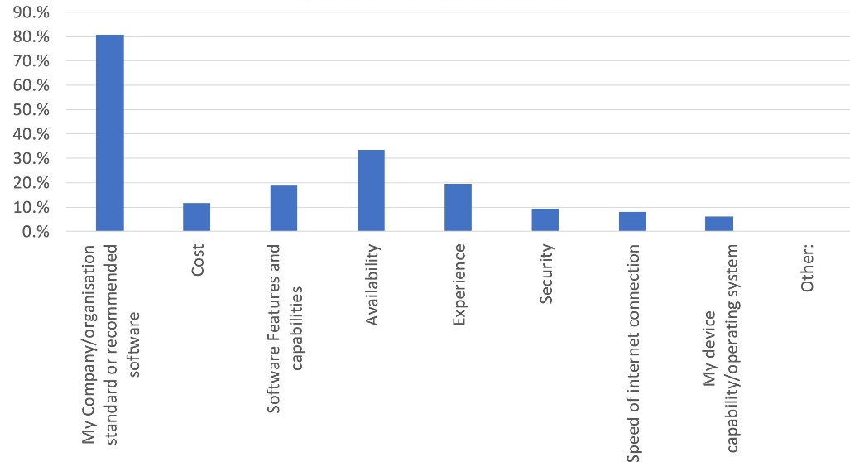

Figure 1.6.1 recognized problems of companies

According to the survey not only the companies, but also we could be able to recognize the challenges of remote working and bellow diagram emphasize it very clearly.

Figure 1.6.2: Challenges of remote working

## Hypothesis

In this research the dependent variable is productivity of the company and the independent variable is remote work. According to this research when only finding the challenges can affect to the productivity to keep continue. Therefore, when finding the challenges of remote working, companies and the workers could be able to face any problem regarding any situation and keep the connection with each other by not having any physical meeting. So, then companies can maintain the productivity very easily. Workers also can work without any working stress when finding the challenges and come up with the solutions before facing any problem.

## Thesis structure

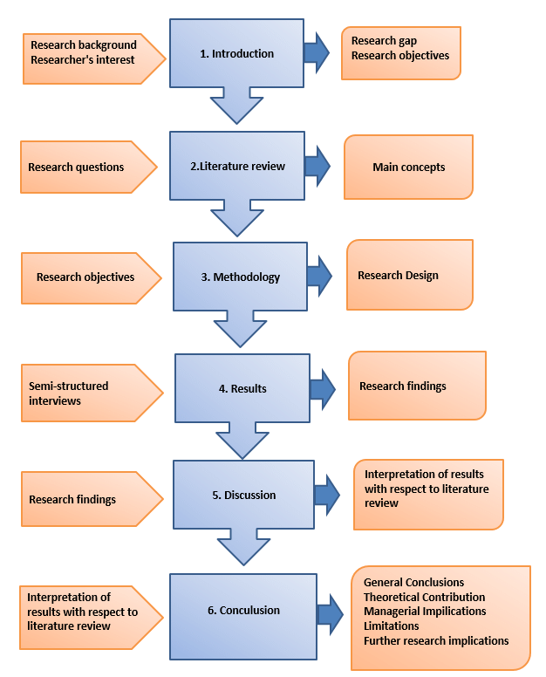Figure 1.8.1: Thesis structure

# CHAPTER 2 - LITERATURE REVIEW



## Literature Review

The main purpose of the speech recognition is to find that what was challenges of the working from in the COVID 19 pandemic situation and find the solutions for this situation. Therefore, regarding this pandemic situation mainly most of the countries need to maintain their productivity as same as previous productivity. In that situation people need to continue their connectivity with each other and continue their lifestyle as before starting the pandemic situation.

In last 2020, one research was carried out by the “International Journal of Information Management”. This was aimed to “Normalising the “new normal”: Changing tech-driven work practices under pandemic time pressure” (International Journal of Information Management, 2020). According to their research the mainly focuses on the changing nature of the work and the adoption of remote working practices.

On that research they argue that it is very essential for a more reflective ‘normalisation’ of work practices and the role technology plays. In that case it is mainly emphasize that there need to start a little training or otherwise, reflection on how to practice and associated with the technology should be introduced. And also, it recognized that should integrated or else adapted to suit the new workplace context.

As same as previous in last 2020, another research was carried out by the “International Journal of Information Management” (Journal of Management Studies, 2020 ). According to their research, they have explored about the impact of the Covid-19 pandemic on technology and innovation management research. They have identified the key assumptions mainly and then; they have discussed about how new areas of investigations are emerge based on the changed reality. And also, they have discussed that social contagion, digital transformation and speed of adoption as well. Therefore, they could be able to find how the pandemic situation was mainly impact for workers.

It is careered out “ (International Journal of Information Management, 2020)” that have published in 2020 by “ELSEVIER”. It is mainly focuses on the development of contact tracing digital applications all over the world by using a special survey. Not only that but also, they focus on the public consciousness of online privacy, personal and national attitudes to privacy. According to the research it is found that, because of the digital contact tracing for COVID-19 remains in its infancy, protection of human and their privacy may already have impeded its capacity to contribute to this pandemic response.

## Conceptual framework

**Independent variable -** Remote working

**Dependent variable -** High productivity

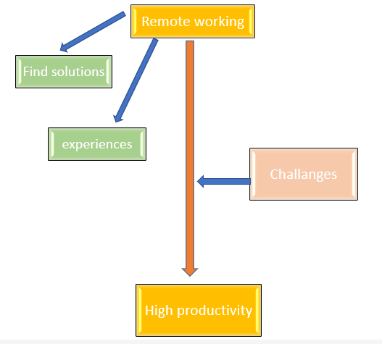

Figure 2.2.1: Conceptual framework

According to this diagram it emphasizes that challenges are directly effected to the productivity. When only finding solution by facing to the challenges and getting experience is the main key to successful the productivity and continue the productivity by working at home.

# CHAPTER 3 – METHODOLOGY



## Research philosophy

This research is interesting focusing on the companies who need to face the challenges when a pandemic situation. This mainly aims that the economy of the country. Regarding the Covid 19 pandemic situation the counties productivity were decreased day by day, therefore, people need to maintain the previous productivity when even a pandemic situation.

In here this research mainly focusing the companies and the workers to how to face this pandemic and make he solution by their own. It is so interesting about to know more information about the economical way in a country. To keep the economy in a good manner people, need to work as previously. Therefore, as a solution people work from home to maintain the productivity. So in here it emphasizes that how to be more productive when working remotely and keep the connection with each other even nt having any physical meeting.

## Research strategy

According to the research topic first collect all the information from the outside and then gather sample surveys regarding this research. Then by using the secondary data from the other samples , observations, media and articles. Finally gathering information and finalize the research project.

## Time frame

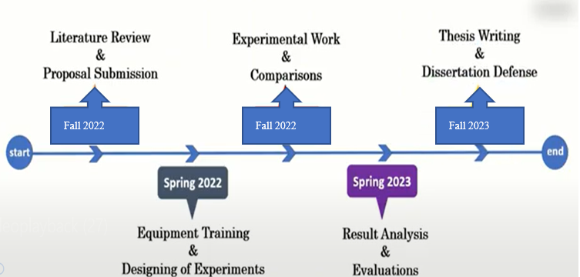

Figure 3.5.1 :Time frame

## Data collection procedures

## Data Collection Method

* Sample Survey
* Secondary data from researches
* Questionaries
* Media
* Articles
* Research papers

## Data Collection and Analyze Tools

* Survey
* Scatter diagram
* Histogram
* Pie chart
* Control chart
* Bar charts
* Box and whisker plot

## Ethical issues of the research study

* Privacy of the economical details in each and every country.
* Privacy of the company details and the workers details.
* Maintaining the confidentiality of the important data.
* Behavior and the objectivity of this research.
* Constant and agreements
* Minimizing risk of harm to participants
* Serious concerns and safeguarding
* Minimizing harm to the researcher.
* Researcher and participant relationship.

# CHAPTER 4 - PRESENTATION OF RESULTS



## Demographic Analysis

According to the below diagram we can understand how the productivity has decreased when the pandemic starts.

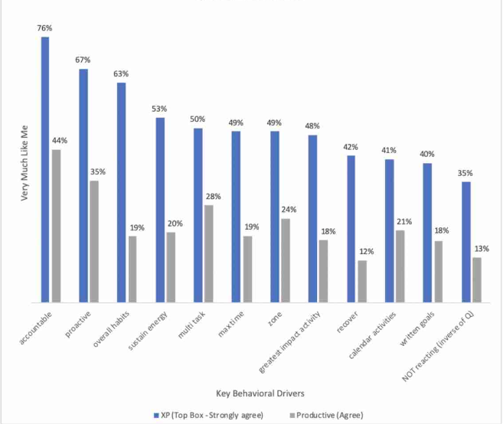

Figure 4.2.1: demographic analysis of the research study

## Regression Analysis

We could be able to finalize the decreasing of the productivity.

Figure 4.2.1: Regression Analysis

# CHAPTER 5 - CONCLUSIONS AND RECOMMENDATIONS



## Conclusion

Developed countries already had experience of remote working but the other developing countries had not that much experience of working from home. In last 2019 we have faced to COVID 19 pandemic as global situation. Therefore, countries and people need to face this pandemic as together. In that case remote working is invented and recommended. Regarding this pandemic all are face huge challenge by working remotely and continue the productivity. Therefore as a result companies had to find all the challenges of remote working and need to be trained all the workers to working remotely with keep the connection with each other.

In this research I emphasized that how to find challenges and opportunities, how to face this pandemic as humans, how to keep the productivity by connecting with each other by using online method and also help the workers to face the challenges better. So then, people can move on with past useless things and go with the modern technologies and techniques. For that people need to be vary careful and to be strong to face any kind of pandemic situation and keep continue the productivity of the work

## Limitations

* Sample profile – this use to find more samples to collect data to this research paper.
* Sample size - when using a sample size to this research it is so difficult to maintain the sample. So, need to find a best sample size because this is about to productivity.
* Data collection process - When taking a survey or taking questionnaires are so difficult to handle this problem. Therefore, need t take future sample is the best.

## Future Improvements

* When collecting data to this research it is so hard to collect data because of the research area scope is so high. Therefore, when finding data to the research for improvements it is better to use future sample for do more modifications to this research.
* And also, according to this research I thought to find more challenges and need to improve this with each and every employee to take a better understanding of this.

## Personnel Reflection

### Benefits for the researcher

I have done this research before reading more than twenty research papers. Therefore, first of all this may help me to enhance my readability and improve my English language skills. Other than that,

* I could be able to find more information about pandemic situation.
* As a student, I could be able to find the challenges as a future worker.
* Could learnt that how to find solutions for the problems.
* Learnt that how to face any problem as a human in these kind of global pandemic situations.
* Could be able to know information regarding the economy of the counties.
* Could be able to come up with the solutions for modern world problems.

### Benefits for the Industry/organization

* Companies could be able to find that what are the challenges d the have to face in a pandemic situation and when remote working
* Workers also could be able to recognize the challenges.
* Companies and workers could have a better knowledge that how to face for those mentioned challenges.
* Companies can have a better idea to maintain their productivity.
* Workers as same as the companies can take a good experience by using the methods that have already mentioned here.
* Workers could be able to work more actively by using the experience knowledge.

# Referencing

“Ovidius” University Annals, 2020. *Economic Sciences Series.* [Online]   
Available at: https://stec.univ-ovidius.ro/html/anale/RO/2020/Section%203/35.pdf  
[Accessed 1 January 2020].

Bluescape, 2020. *Bluescape.* [Online]   
Available at: https://www.bluescape.com/blog/5-charts-revealing-management-views-on-working-from-home  
[Accessed 15 June 2020].

fireflies.ai, 2021. *fireflies.ai.* [Online]   
Available at: https://fireflies.ai/blog/remote-work-loneliness  
[Accessed 27 May 2021].

International Journal of Information Management, 2020. COVID-19, digital privacy, and the social limits on data-focused public health responses. *ELSEVIER,* Volume 55.8, p. 6.

International Journal of Information Management, 2020. Normalising the “new normal”: Changing tech-driven work practices under. *ELSEVIER,* Volume 55, p. 6.

International Journal of Information Management, 2020. *ScienceDirec.* [Online]   
Available at: https://www.sciencedirect.com/science/article/pii/S0268401220308422  
[Accessed Desember 2020].

International Journal of Information Management, 2020. *ScienceDirect.* [Online]   
Available at: https://www.sciencedirect.com/science/article/pii/S0268401220310239  
[Accessed 01 December 2020].

JMIR Public Health Surveill., n.d. *The National Center for Biotechnology Information.* [Online]   
Available at: https://www.ncbi.nlm.nih.gov/pmc/articles/PMC7759507/  
[Accessed 23 December 2020].

Journal of Management Studies, 2020 . What has changed? The Impact of Covid Pandemic on. *Journal of Management Studies,* Volume 57.8, p. 5.

Market Insights, Growth & Productivity, 2020. *Wahl and Case.* [Online]   
Available at: https://www.wahlandcase.com/blog/how-to-keep-everyone-motivated-when-working-remotely  
[Accessed 8 May 2020].

NAN JIANG and JULIE RYAN, 2020. *World Bank Blogs.* [Online]   
Available at: https://blogs.worldbank.org/developmenttalk/how-does-digital-technology-help-fight-against-covid-19  
[Accessed 29 May 2020].

# Annexures

## Annexures A: Glossary of Terms

## Annexures B: Sample SPSS Charts/ Table

## Annexures C: Feedback Form / Question list

## Annexures D: Sample Feedback sheets